***Technical Design***

*Version 1.0.*



*Name: Aron Dosti*

*Student id: 115827*

*Date: 31/05/2020*

*Table of contents*

Introduction ……………………………………………………………………….….………………………….. 3 Summary …………………………………………………………………………….….…………………………. 3 Requirements ……………………………………………………………………….….…………………………4 Technical Specifications ......................................................................................... 4 Functionalities ........................................................................................................ 5 User Case ............................................................................................................... 7 Output Design ........................................................................................................ 7 Relational Datamodel ........................................................................................... 12 Data Dictionary …………………………………………………………………..…………………………… 13 Version Control ………………………………………………………………….………….………………… 15

# 1.Introduction

In this Technical document there is going to be explaining about all the technical requirements and other important information for the Hotel California website. This document consists of:

* The introduction
* Summary
* Requirements
* Technical Specifications
* Functionalities
* User Case
* Output Design
* Relational Datamodel
* Data Dictionary
* Version Control.

# 2.Summary

To summarize this document for you, there will be explaining about all the Technical requirements that are being used for this website and shown to the viewers. Not only that but there will also be an explanation about the Database and how this database functions. At last there will be Functionalities viewed such as the use case, Database diagram (also known as ERD) and a Flowchart. We have to keep in mind that this document is still under maintenance and the versions of this document might get changed in the further weeks, but no worries the old version files will be kept and dated so that we can look back at old information of the Technical Design. A date will also be kept by.

# 3.Requirements

For this Website there will be these basic Requirements for making the website function. The Hotel California website will need:

* A Database
* A computer or laptop
* A Code Editor (for this website, there will be a usage of Visual Studio Code)
* PHP functions
* Front-End code
* Back-end code
* Designs
* UML designs.
* Hosting test server (Xampp)
* Internet
* Microsoft office or OpenOffice (to make documents for the companies)
* FTP Programs or Plugins like Filezilla or FireFTP (to put Files on the (school)server)

# 4.Technical Specifications

As technical specifications we will need the Functions such as a Reservation system and a login system and other minor functions. Here are the 4 important subsystems that the website demands:

1. Room administration subsystem:
   1. The hotelkeeper must be able to add the category of rooms available in the system.
   2. The hotelkeeper must be able to see a room plan with the location of the rooms.
   3. In the room plan the hotelkeeper must be able to assign the category that the room belongs to.
   4. The hotelkeeper must be able to print a list of rooms and the category they belong to.
2. The pricing Subsystem:
   1. The reservation desk must be able to assign a room price for the one of the 3 categories of rooms (family, single, double rooms) for a period of time or a certain day of the year.  
      The pricing system must be completely filled in, at least 3 months in advance.
   2. The reservation desk must be able retrieve a list of room prices per day. They must be able to print this list.
3. The web reservation system:
   1. Web visitors must be able to see the available categories of rooms and the prices for those categories from a certain start- to an end date. When the prices differ during the period, it is also showed on the website. Per room category the visitor will see some photos on the website and a video in an appropriate web format. The visitor will also see the amount of rooms available per category.
   2. The web visitor must be able to make a reservation. While making the reservation the visitor must be able to enter his name, first name, home address, city, country, telephone number and email address. After entering the reservation the visitor will receive a confirmation email that will include the invoice.
   3. The hotelkeeper must be able to see and print a list of occupied and reserved rooms within a certain period.
4. The front desk system:
   1. The front desk must be able to print a list of room prices for a week.
   2. The front desk must be able to see all unoccupied and the amount of “not reserved” (vacant) rooms on a certain day per category.
   3. The front desk must be able to register a guest as an occupant of a room.
   4. The front desk must be able to see if the room is prepaid or post-paid.
   5. In case of post-paid rooms the front desk must be able to print an invoice for the room rent (fee) that is due.

# 5.Functionalities

For the Functionalities it is important to know how the website will work and how to book a room. Here is a full Activity diagram of the booking system:

(the Activity diagram is very large and for that it is handy to zoom the Word page or PDF in so that the diagram looks more visible.)

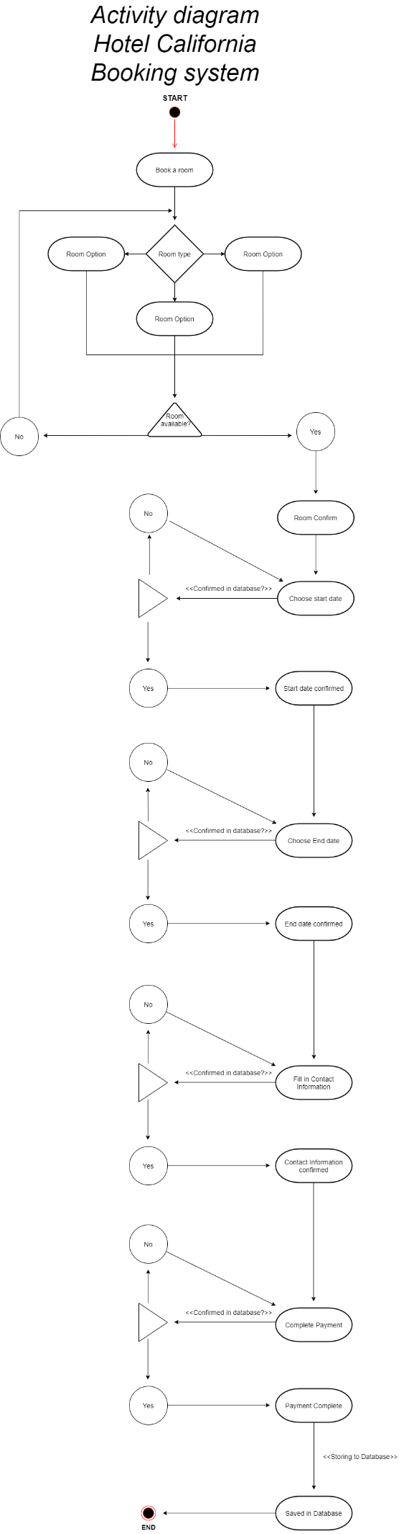

# 6.User Case

The website will be made by a Lenovo ideapad 330 15 ich. The specs are:

- 15,6" FHD (1920 x 1080) IPS

- memory: 4 GB DDR4 Intergraded + 8 GB DIMM .

- Operating system: Windows 10.

* Graphics cart: Tot NVIDIA® GeForce® GTX1050
* AMD Radeon™ 540 (onboard)
* Intel Integrated Graphics.

- Processor: Intel® Quad Core i7-8550U From the 8e generatie.

# 7.Output Design

For the output design there will be wireframes, use case and a navigation structure included and shown.

***Wireframes:***

***Home***

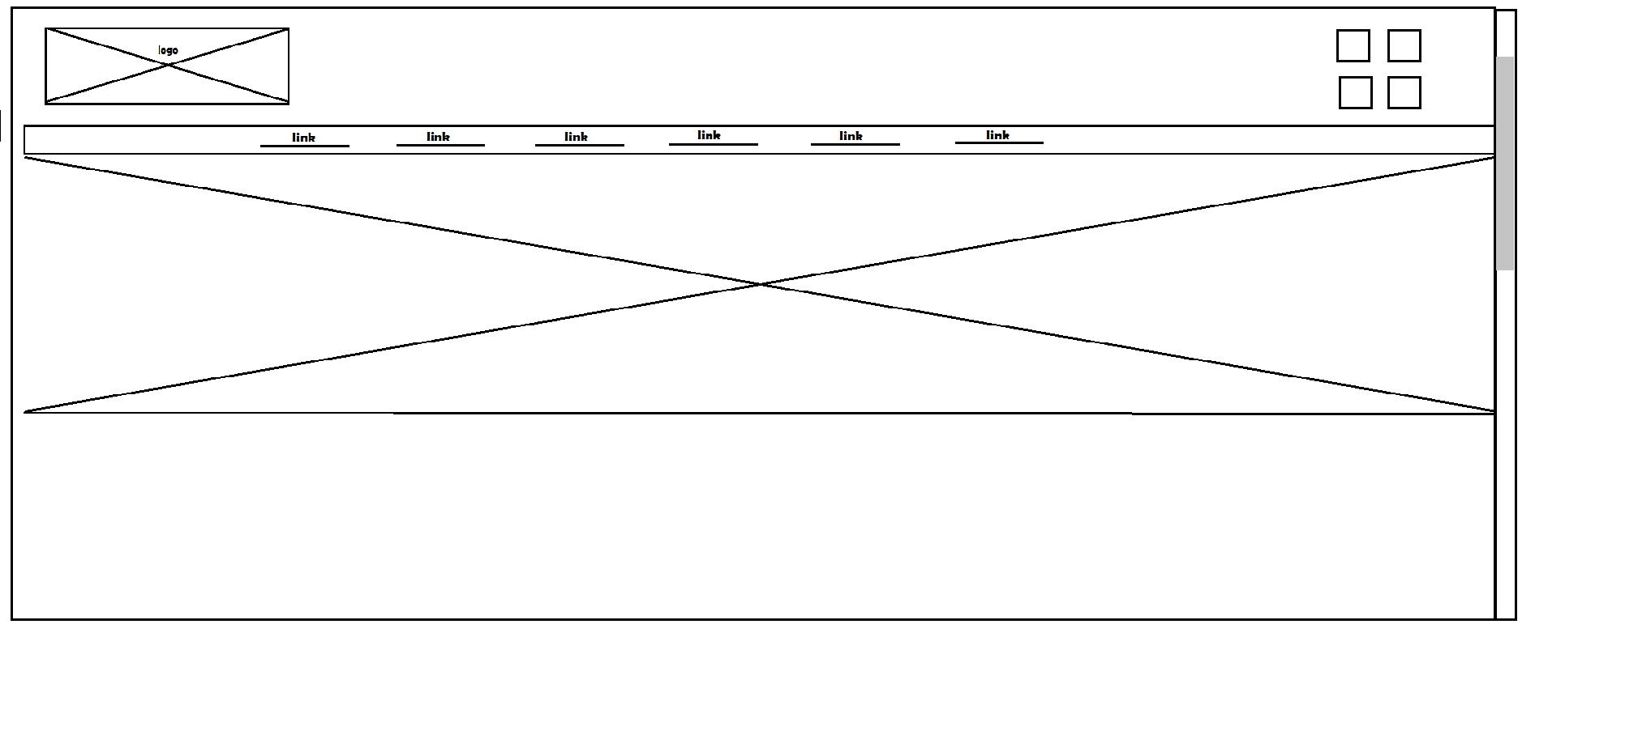

***Contact***

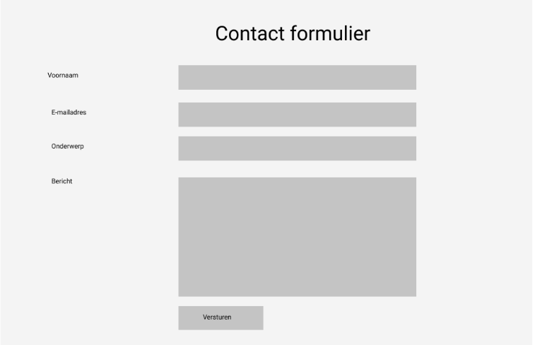

***Login***

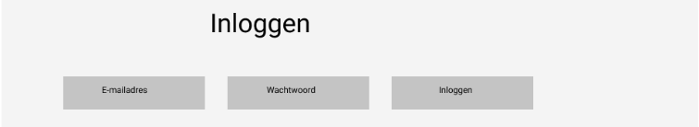

***Reservation***

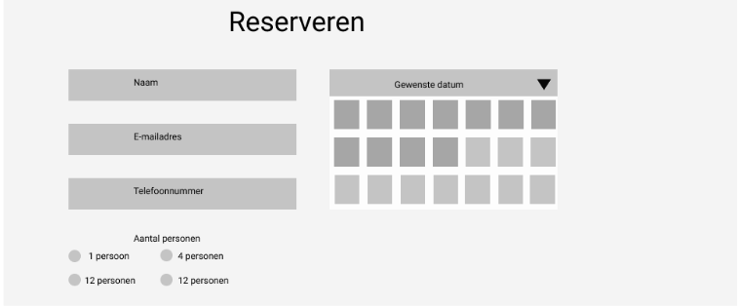

***Book a room***

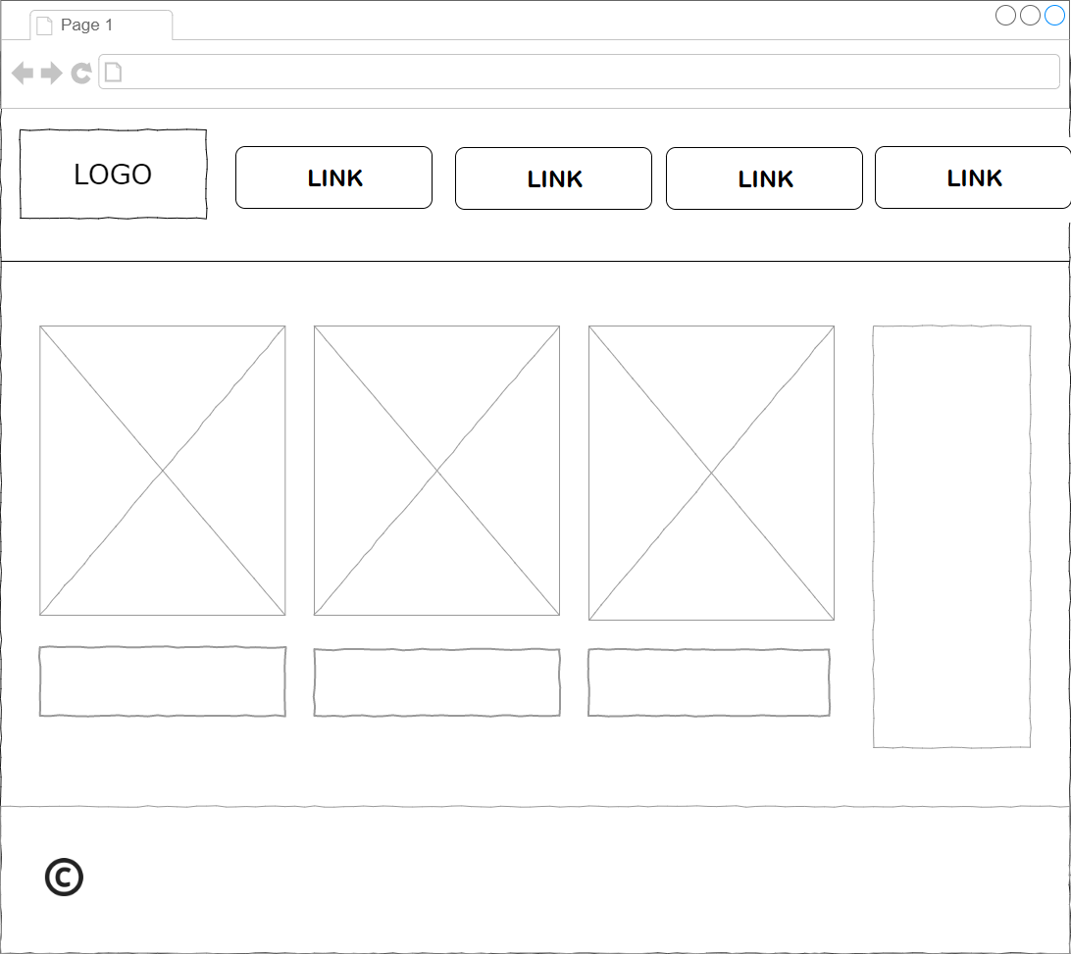

***Use Case:***

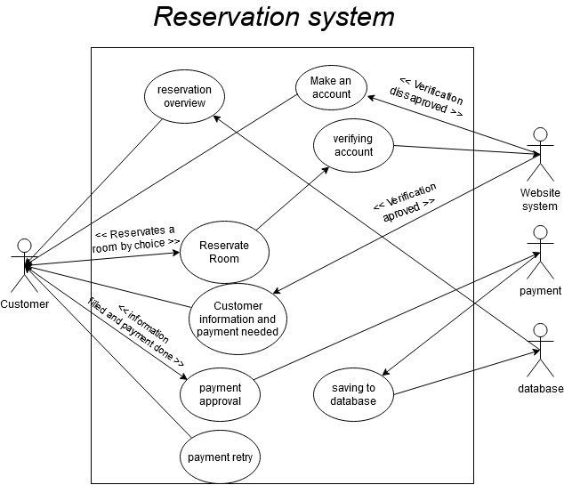

***Navigation Structure:***

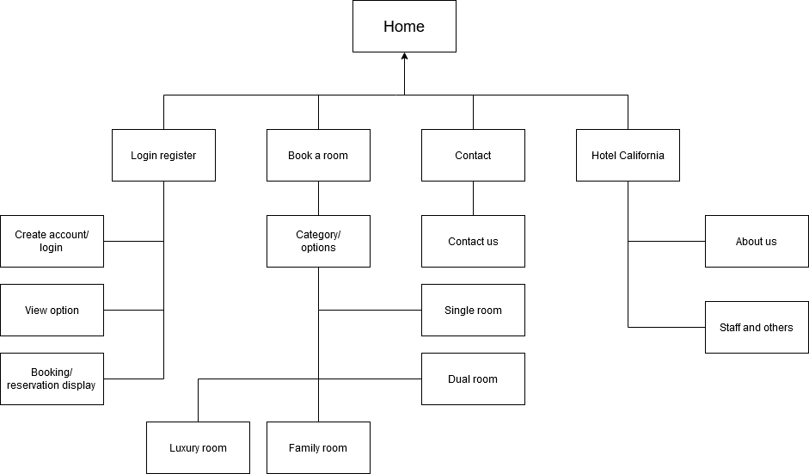

# 8.Relational Datamodel

in the relational Datamodel there will be an explanation about the ERD (entity Relationship Diagram) of Hotel California. The ERD will also be shown.

***What is an ERD?:*** To keep it simple, an ERD or Database diagram is a design of a Database. These database designs contain tables of information and with a few tables there comes a relation or connection between them (you can see the relations to each other by the strings).

***The ERD:***

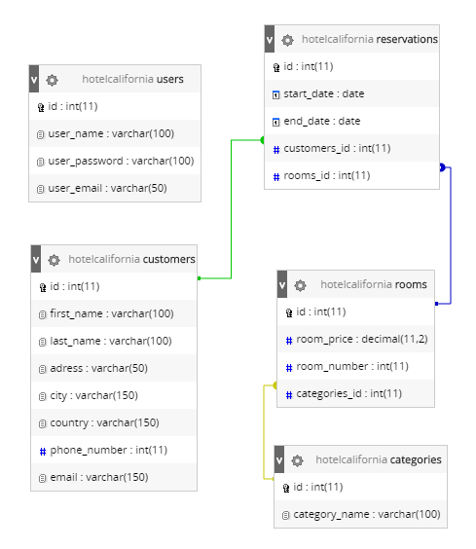

# 9.Data Dictionary

***Customer***

|  |  |  |  |  |
| --- | --- | --- | --- | --- |
| Field name | Data type | Field size | Description | Example |
| id | Interger | 11 | Main unique Id key | 3 |
| First_name | varchar | 100 | First name of the customer | Billy |
| Last_name | varchar | 100 | Last name of the customer | Butcher |
| adress | varchar | 50 | Adress of the customer | Hakelmeerstraat,  2729sd,  27 |
| city | varchar | 150 | City of the customer | Den haag |
| Country | varchar | 150 | Country of the customer | netherlands |
| Phone_number | interger | 11 | Phone number of the customer | 0646284789 |
| email | varchar | 150 | Email adress of the customer | test@test.com |

***Reservations***

|  |  |  |  |  |
| --- | --- | --- | --- | --- |
| Field name | Data type | Field size | Description | Example |
| id | Interger | 11 | Main unique Id key | 3 |
| Start_date | Date | … | Tells you when the reservation began | 12/4/2012 |
| End_date | Date | … | Tells you when the reservation ended | 30/4/2012 |
| Customer_id | Interger | 11 | Refers to customer table as relation | 3 |
| Room_id | interger | 11 | Refers to room table as relation | 3 |

***Rooms***

|  |  |  |  |  |
| --- | --- | --- | --- | --- |
| Field name | Data type | Field size | Description | Example |
| id | Interger | 11 | Main unique Id key | 3 |
| Room_price | decimal | 11,2 | Tells you what the value of a room is | $299,99 |
| Room_number | Interger | 11 | Tells you which room it is | 31 |
| Categories_id | Interger | 11 | Refers to categories as relation | 3 |

***Users***

|  |  |  |  |  |
| --- | --- | --- | --- | --- |
| Field name | Data type | Field size | Description | Example |
| id | Interger | 11 | Main unique Id key | 3 |
| User_name | varchar | 100 | Tells you what the username of the account is | Billybutch |
| User_password | varchar | 100 | Tells you what the password of the account is | Cbaksdfg329649 (encrypted) |
| User_email | varchar | 50 | Tells you what the email of the account is | billy@hotmail.com |

***Categories***

|  |  |  |  |  |
| --- | --- | --- | --- | --- |
| Field name | Data type | Field size | Description | Example |
| id | Interger | 11 | Main unique Id key | 3 |
| Category_name | varchar | 100 | Tells you in what kind of category your room is in | Single room |

# 10.Version Control

|  |  |
| --- | --- |
| *Version* | *Date modified* |
| *1.0* | *31/05/2020* |